Task 9, 1-2 pages, select 3 visuals and examine them, DUE OCT 04 9PM
After a close examination of the visuals, you will select three visuals and answer questions presented on pp. 91 (Identifying the Elements of a Visual Argument) and Checklist Questions presented on p. 99. You may also annotate the visuals, so you may focus your attention on particular elements of the image. You use textual evidence to support your response and write in complete sentences.
Identifying the Elements of a Visual Argument
1. Do you see all of the visuals as arguments, or do you
think some were created solely to present information?
2. What main idea, or message, does each visual communicate? State the
main idea of each visual in a single sentence.
3. What elements in each visual support this main idea?
4. If the visual includes words as well as images, are the words necessary?
5. What purpose does each visual seem designed to achieve?
6. What kind of audience do you think each visual is aimed at?
7. Does the visual appeal primarily to logos, pathos, or ethos?
8. Do you think the visual is effective? That is, is it likely to have the
desired effect on its intended audience?
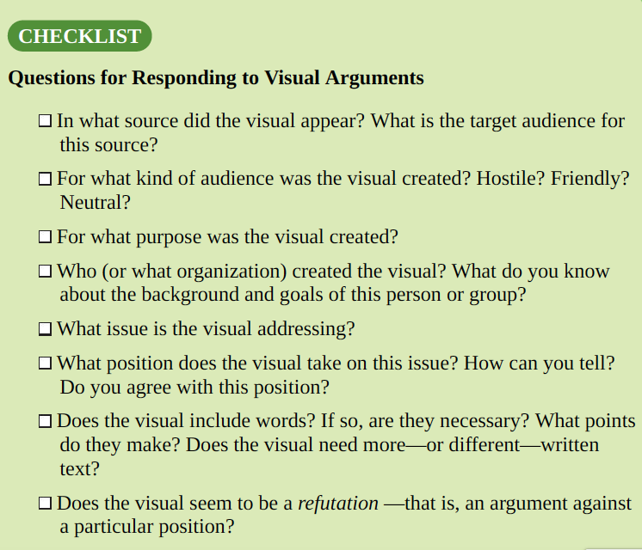
- Bob Engelhart, Violent Video Games
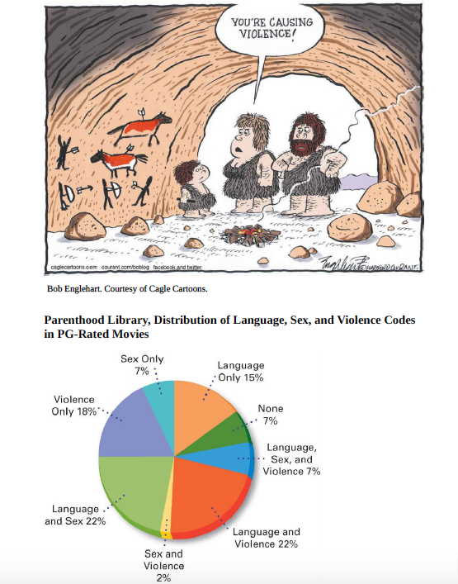
2.

From Amy I. Nathanson & Joanne Cantor (1998), Protecting Children from Harmful Television: TV
Ratings and the V-Chip. From Parenthood in America, University of Wisconsin-Madison General
Library System.

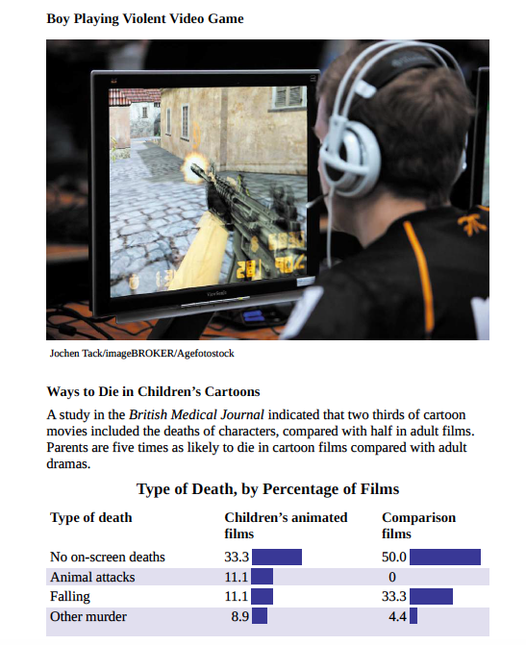
3.

4.

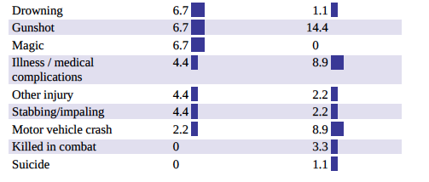

5. Lauren Dazzara, Why Gaming Is a Positive Element in Life
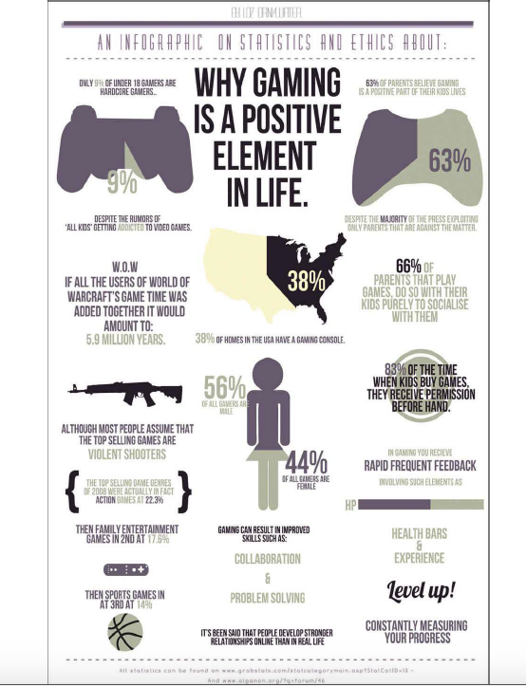

Task 10, 2-3pages, compose a visual argument (on 3 VISUALS), DUE OCT 06 9PM

Assignment Overview
A picture is worth a thousand words, and business leaders realize they can grow their brand by using high-quality visual content. By using visual images, industry leaders can brand their image or market their products more effectively and efficiently. Good leaders also realize that visual images can inadvertently convey messages that are inconsistent with the company's values. Reading visual images is no easy task and requires practice.

Instructions
You will search for three visual arguments of interest to you. After you have selected your visuals, you will read and annotate each visual argument. After reading each visual argument, you will select one visual that you believe presents the strongest visual argument. Next, you will reimagine the visual. As you reflect on your learning in Module 1, remember everything is an argument, and there are two sides to every argument. During your close reading of the visual argument, you will identify the counterargument. After identifying the counterargument, consider how you will reimagine your argument. In brief, you will create a visual counterargument, place it on the reference page.

